ENVS 212

# Week 1

## Lecture 1

### Info

* Instructor: Dane C. Ward
* Office Hours: Mon/Wed 11am-12pm, PISB 302
* Email: [dcw33@drexel.edu](mailto:dcw33@drexel.edu)
* TA: Johannes Krause
* TA Email: [jrk339@drexel.edu](mailto:jrk339@drexel.edu)
* Textbook: Evolution, 4th Edition - Douglas J. Futuyma, Mark Kirkpatrick, Sinauer Associates (Oxford University Press), ISBN 978-1605356051
* Top Hat Link: 118271
* Final Exam: In-class on June 8th

### What is Evolution?

* Biological Evolution
* Changes in the genetic properties of groups of organisms (“populations”) over the course of generations
* Often referred to more simply as “**descent with modification**” or “genetic change over time”
* Evolution is about change in *proportions* through time
* Within Populations
* Change in gene frequencies between generations (e.g. shift in proportion of individuals with dark versus light wing coloration)
* Between Populations (or species)
* Change in proportion of genetically differentiated populations (e.g. shift in proportion of populations with dark versus light wing coloration)

### Why is Evolution Interesting?

* Morphological Diversity
* Why do whales have lungs and snakes lack legs?
* Evolution is the only scientific explanation for many observed anatomical traits
* Genetic Diversity
* Why do salamanders have 10x more DNA than humans?
* Human Genome
* ~3.2 billion base pairs
* Some Salamanders
* ~120 billion base pairs
* Species Diversity
* Why are there so many species of insects?
* Medicine
* How do bacteria, viruses, and parasites counter our immune system?
* How do bacteria, viruses, and parasites evolve resistance to our medicines?
* Technology
* How do insects evolve resistance to pesticides?

## Lecture 2

### Misconception #1

* ~~Evolution and natural selection are the same thing~~
* Natural selection is ONE mechanism by which evolution occurs, but natural selection and evolution are NOT one and the same
* Evolution is simply genetic change through time, to deny evolution is to deny genetic change occurs
* But, much evolution occurs due to natural selection

### Misconception #2

* ~~Individual organisms undergo biological evolution~~
* Populations or groups of organisms undergo evolution
* In biology, the change of individual organisms through their lifetime is termed “development”

### Misconception #3

* ~~Evidence for evolution is limited, it is only an unsubstantiated theory~~
* Evidence for evolution is abundant, stemming from numerous sources such as from the fossil records, DNA and genomic data, and direct observations in contemporary time

### Three Examples of Evidence for Evolution

* Antibiotic resistance
* Pesticide resistance
* Experimental evolution studies in the laboratory

### Evolution by Natural Selection in the Laboratory

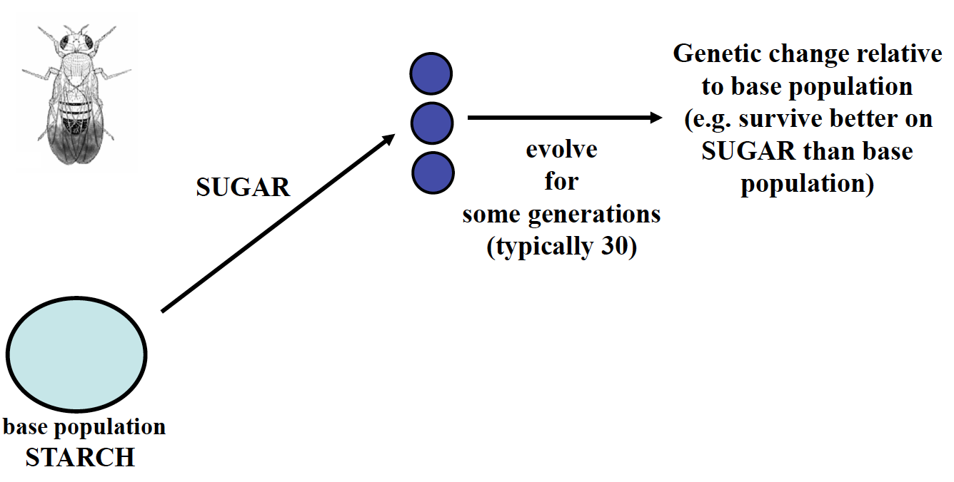

### Misconception #4

* ~~Evolution occurs within species, but it cannot explain the origin of new species~~
* As for studies within species, there is abundant evidence that new species form via evolution

### Evidence for Evolution Through Fossil Records

* ~~There aren’t any intermediate forms between major animal groups, and there are few “missing links”~~
* MANY intermediate forms and “missing links” have been found, with more found all the time

### History of Evolutionary Thought

* Before Darwin (pre 1859)
* Darwin (1859)
* Theories after Darwin (early 1900s)
* The evolutionary synthesis (1930s, 1940s)
* Biology since the synthesis (1950 on)

### Before Darwin

* Plato and Aristotle
* Concept of eidos “form” or “idea” or “essence”
* e.g. horses have an immutable (unchangeable) essence, but each individual has its imperfections
* This view is called **essentialism** and under this view, variation is accidental imperfection
* In the 18th century, there were profound changes in thinking about the nature and history of the Earth
* Uniformitarianism
* “The present is the key to the past”
* Championed by geologists Hutton and Lyell
* Catastrophism
* Sudden violent and short-lived events were responsible for the current state of the Earth
* Jean-Baptiste Pierre Antoine de Monet, Chevalier de Lamarck
* Developed theories of phenotypic evolution and of speciation
* George Cuvier
* The father of paleontology
* Rejected the Lamarckian idea of evolution
* Endorsed the idea that evolution occurs through catastrophic events
* Suggested that there must be a large catastrophic event to change/rid species, otherwise everything else happened spontaneously

### Lamarck’s Theory of Phenotypic Evolution

* Traits acquired during the course of an individual’s lifetime were passed on to offspring
* e.g. lengthening of giraffe’s necks and thickening of blacksmith’s arms

### Lamarck’s Theory of Speciation

* Species originate by spontaneous generation, and have not originated from common ancestors

### Darwin’s Life

* Lived 1809-1882
* Voyage of the Beagle Island 1831-1836
* Darwin became an accomplished naturalist
* Theory formulated via INDUCTION

### Logic

* Use General Principles to Deduce to Specific Instances, which you then Induct into your General Principles
* General Principles –Deductive🡪 Specific Instances –Inductive🡪 General Principles

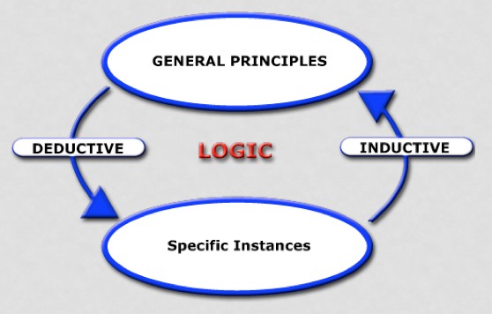

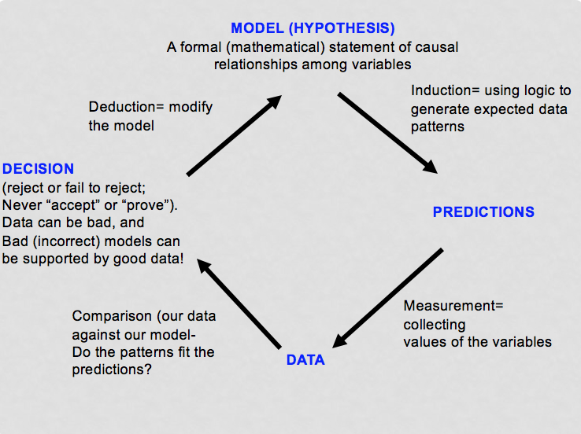

## Lecture 3

### Darwin’s Life Cont’d.

* After formulating his theory, he spent much time trying to sort out flaws
* Published the Origin of Species in 1859 (> 150 years ago)
* The power and brilliance of Darwin’s idea of natural selection is often underestimated
* The idea was one of the most important, general, and powerful ideas in the history of thought

### Origin of Species

* Two major theses
* Descent with modification (evolution)
* A succinct term to describe biological evolution
* Causal agent of evolutionary change (natural selection)
* A differential survival or reproductive success of classes of entities that differ in one or more characteristics
* Usually the differences are inherited (and must be inherited for evolution by natural selection)
* Five theories
* Evolution as such
* The simplest proposition that the characteristics of lineages of organisms change over time
* Common descent
* All life could be portrayed as one great family tree
* A radically new view of evolution
* Gradualism
* The proposition that differences between even radically different organisms have evolved incrementally, by small steps through intermediate forms
* Population change
* The thesis that evolution occurs by changes in the *proportions* of individuals within a population that have different inherited characteristics
* Natural selection
* Darwin’s brilliant hypothesis (independently conceived by Wallace) that the proportional changes described above are caused by differences in their ability to survive and reproduce, and that such changes result in the evolution of *adaptations*

### Natural Selection as a Cause of Evolution

* Early in Generation 1
* Heritable (genetic) differences in phenotype
* 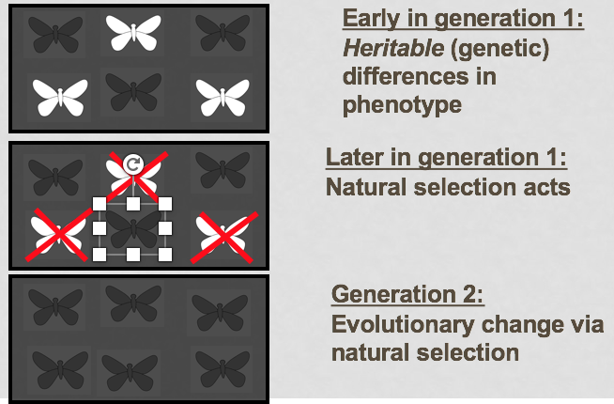Later in Generation 1
* Natural selection acts
* Generation 2
* Evolutionary change via natural selection

### Darwinian View

* Variation is adaptive, evolved by natural selection

### Alfred Russel Wallace

* “Father of Biogeography”
* Wallace Line
* Drawn in 1850
* 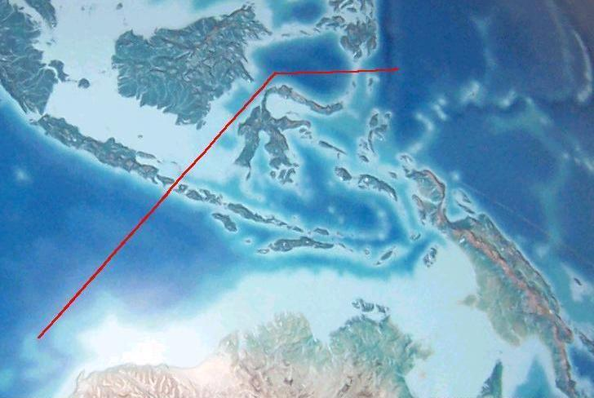Separates the ecozones of Asia and Wallacea, a transitional zone between Asia and Australia
* Wallace Effect
* Explanation for Speciation
* Natural selection can contribute to the reproductive isolation of incipient (developing) species by evolving barriers against hybridization

### Evolutionary Theories after Darwin

* Theory was initially very controversial
* Idea of evolution by common descent eventually accepted
* But, the idea that natural selection caused evolution was debated
* Led to the rise of **mutationist theories** which argued that discretely different organisms arose via mutation and that natural selection was not required for the origin of new species
* Mutation seen as an *alternative* to natural selection
* Mendelian genetics
* “Particulate inheritance”
* 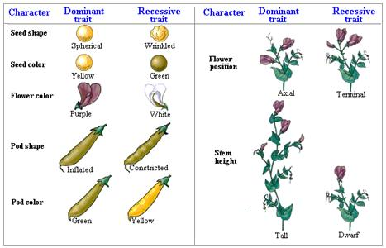Ideas were published in 1865 but nearly completely ignored

### Richard Goldscmidt (1940) and “Hopeful Monsters”

* Macroevolution through macromutation

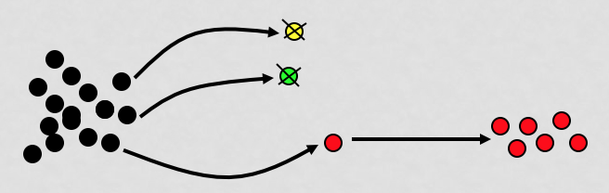

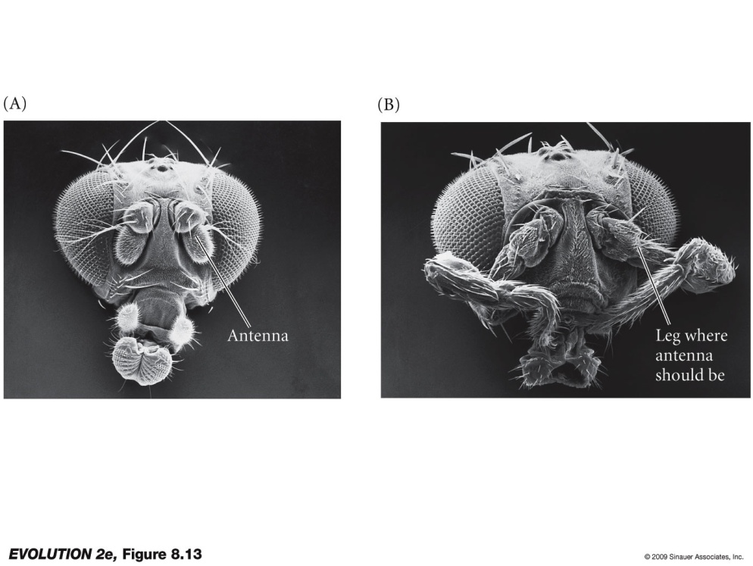

### The Modern Evolutionary Synthesis (1930s and 1940s)

* Forged from the contributions of genetics, ecologists, systematics, and paleontologists
* Reconciled Darwin’s theory with facts of (Mendelian) genetics
* Has been extended, clarified, and modified since 1940s, but is still generally considered fundamentally valid

### Ronald A. Fisher, J. B. S. Haldane, Sewall Wright

* Developed a mathematical theory of population genetics, which showed that mutation and natural selection *together* cause adaptive evolution
* Mutation is not *alternative* to natural selection, but is rather it’s *raw material*
* The relative importance of random genetic changes versus natural selection in evolution was debated

### Founder Effect and Genetic Drift

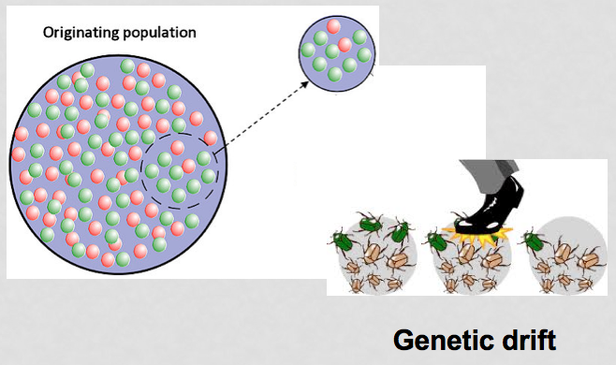

### Ernst Mayr

* Three major contributions
* Biological species concept (BSC)
* Species are groups which are reproductively isolated (do not exchange genes) from other groups
* Theory of geographic (allopatric) speciation
* New species form when populations become geographically isolated, and thus can undergo genetic divergence
* Theory of founder effect speciation
* Drastic reductions in population size promote speciation
* e.g. “genetic revolutions

### Fundamental Principles of Evolution (Major Tenets of Modern Synthesis)

* The **phenotype** (observed characteristics) is different from the **genotype** (the set of genes in an individual’s DNA)
* Phenotypic differences can be partly due to genetic differences and partly due to direct (within generation) effects of the environment
* Heredity variation are based on particles (**genes**) that retain their identity as they pass through generations
* Evolutionary change is a *populational process* that entails changes in the proportions or frequencies of individual organisms with different genotypes
* Genes mutate at a low rate, typically too low a rate to cause a population to shift from one genotype to another
* Thus, shift occur instead by random fluctuations (**genetic drift**) and nonrandom changes due to **natural selection**
* Even a slight amount of selection can bring about substantial genetic changes, thus selection can account for both slight and extreme genetic differences
* Mutations can accumulate in populations, thus populations harbor genetic variation
* Differences between populations and species are often **adaptive** (evolved due to natural selection) and are based on differences at several or many genes of small effect (evolution occurs by small steps)
* Species are characterized by barriers to genetic exchange and interbreeding (**reproductive isolation**), and usually evolve in geographic isolation
* All organisms form a great “tree of life” or **phylogeny**
* All forms of life have descended from a single common ancestor in the remote past

# Week 2

## Lecture 1

### Motoo Kimura and the Neutral Theory of Molecular Evolution

* Natural selection requires phenotypic variation to act upon
* But many genetic changes cause no phenotypic change (do not produce phenotypic variation)
* Led to the hypothesis that most of the evolution of DNA sequences occurs by genetic drift, rather than natural selection
* But, it provides a foundation for detecting natural selection on DNA sequences

### ../../../../../Pictures/Screenshots/Screen%20Shot%202018-04-09%20at%201.55“Wobble” Position

### William D. Hamilton, Robert Trivers, and Social Theory

* Cooperation
* **Kin selection** (explains confusing altruistic behaviors and eusociality)
* Conflict
* Parent/offspring, sibling, male/female

### The Age of Genomics (A New Age of Induction)

* New insights into the size, organization, and structure of genomes
* In turn, this information yields insight into the causes and consequences of evolution

### Taxonomy and Systematics

* Taxonomy
* The science of describing, naming, and classifying organisms
* Taxon (plural = taxa)
* A unit of taxonomic classification
* Systematics
* The study of biological diversity and the evolutionary relationships among organisms
* Testing hypotheses about which groups have descendants from a common ancestor
* Extinct
* No longer present
* Extant
* Taxa that exist today
* Phylogeny
* The history of descent of a group of taxa from their common ancestors
* Phylogenetics
* Study of phylogenies
* Phylogenetic trees
* The diagrams that depicts phylogenies
* A systematic hypothesis

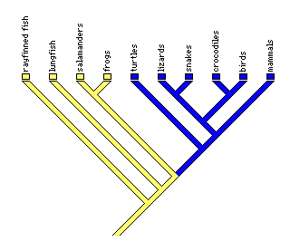

### Taxonomy

* Used to organize groups of species into progressively smaller hierarchical groups
* Originally Kingdom was the most inclusive taxonomic group

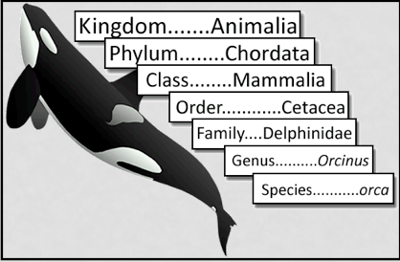

* “Five kingdom” system was used for many years
* Monera, Protista, Fungi, Plantae, Animalia
* Three domain system
* Eukarya, Archaea, Bacteria
* One purpose of taxonomy is to name species
* Modern species taxonomy started with Carl Linnaeus
* First introduced **binomial nomenclature** in his 1753 “Species Planatarum” and 1758 “Systema Naturae” editions
* Each species has two parts
* *Megacephala virginica*
* *Megacephala Carolina*

### Systematics

* Relatedness
* The resulting pathway is interesting of itself
* Who is most closely related to pigs?
* Are dogs more closely related to cats or pigs?
* Trait Evoltuion
* Phylogenic trees provide a foundation for understanding many aspects of evolutionary history, such as the pathways by which various creatures evolved
* How many times did wings evolve?
* Cutting Edge Technology
* Use of molecular data, including whole genome sequences
* Detective Work
* Unlike some aspects of evolution, we cannot often directly observe evolutionary history
* Instead, we must infer it using phylogenetic methods, like Sherlock Holmes reconstructing the history of a crime

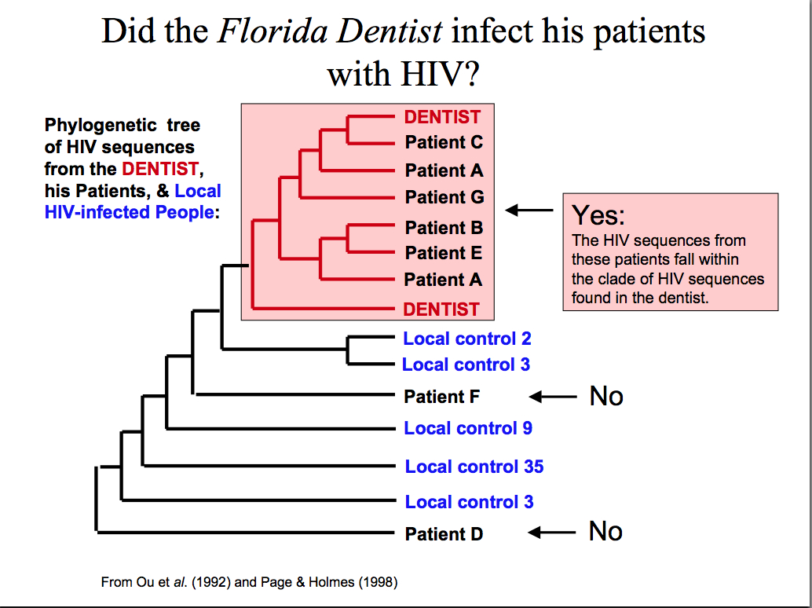

### Phylogenic Tree Terminology

* NOTE: Rotating the branches does not change the relationships
* Root
* The common ancestor of all taxa
* Node
* A branchpoint in a tree
* Clade
* 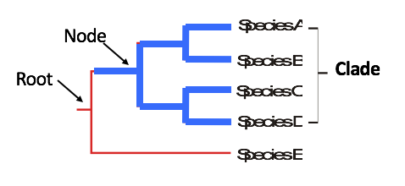A group of two or more taxa that includes both their common ancestors and all their descendants

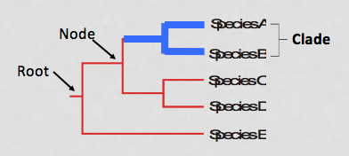

* Monophyletic Group
* A taxon that is a clade
* A group that includes ALL of the descendants of a common ancestor

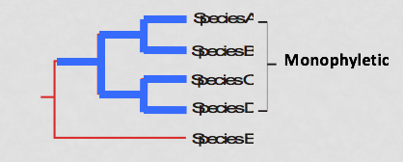

* Paraphyletic Group
* A group that includes some, but not all, of the descendants of a common ancestor
* Polyphyletic Group
* A group that consists of members of multiple evolutionary lineages, but does not include the most recent common ancestor and all of its descendants

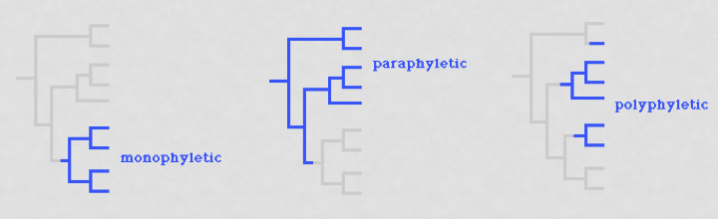

### Inferring Phylogenics

* Character
* A feature or trait (e.g color of snail shell)
* Character States
* One of the variant conditions of a character (e.g. brown or yellow shell, A or T at a nucleotide position)
* Ancestral State
* State found in common ancestor
* Derived State
* State that has evolved from the ancestral state
* Outgroup
* A taxon that is closely related to the study group
* 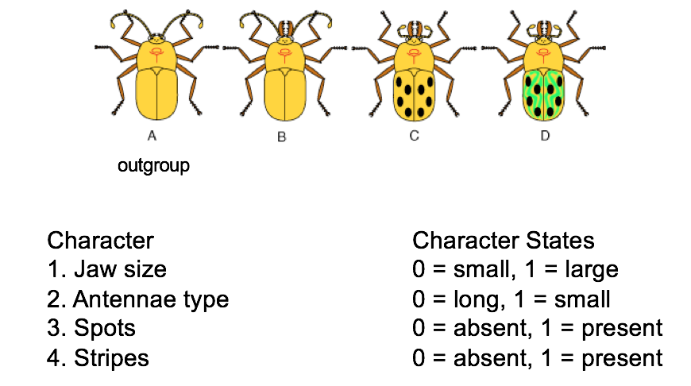Comparisons of character states can inform as to which are ancestral and derived
* Homology
* Same character state found in different taxa due to shared common ancestry
* Analogy (Homoplasy)
* Same character state found in different taxa due to convergent evolution or reversal

